Jackson Warren

Jeremy Bergen

CSCI 370

10/6/21

Week 10: Chapter 9

Section 1:



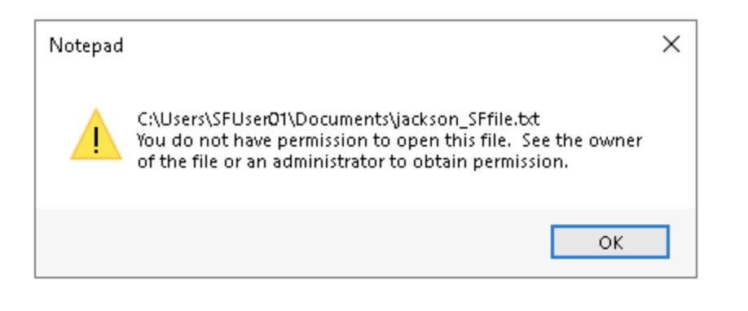

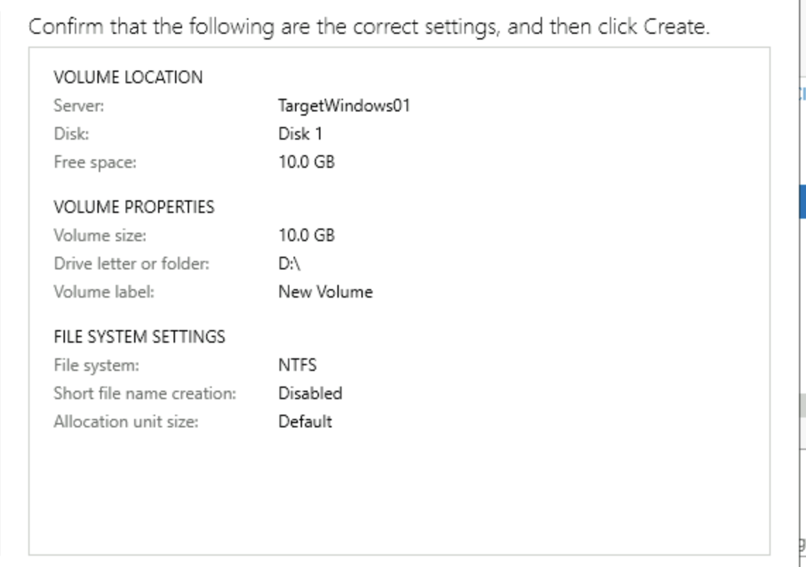

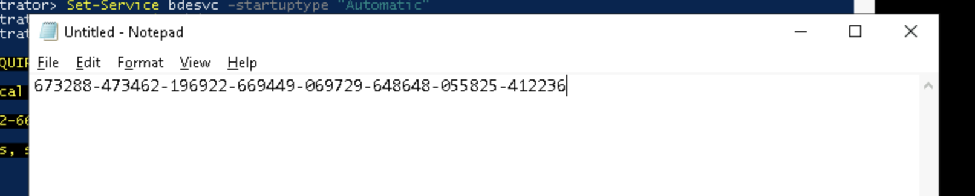



Section 2:



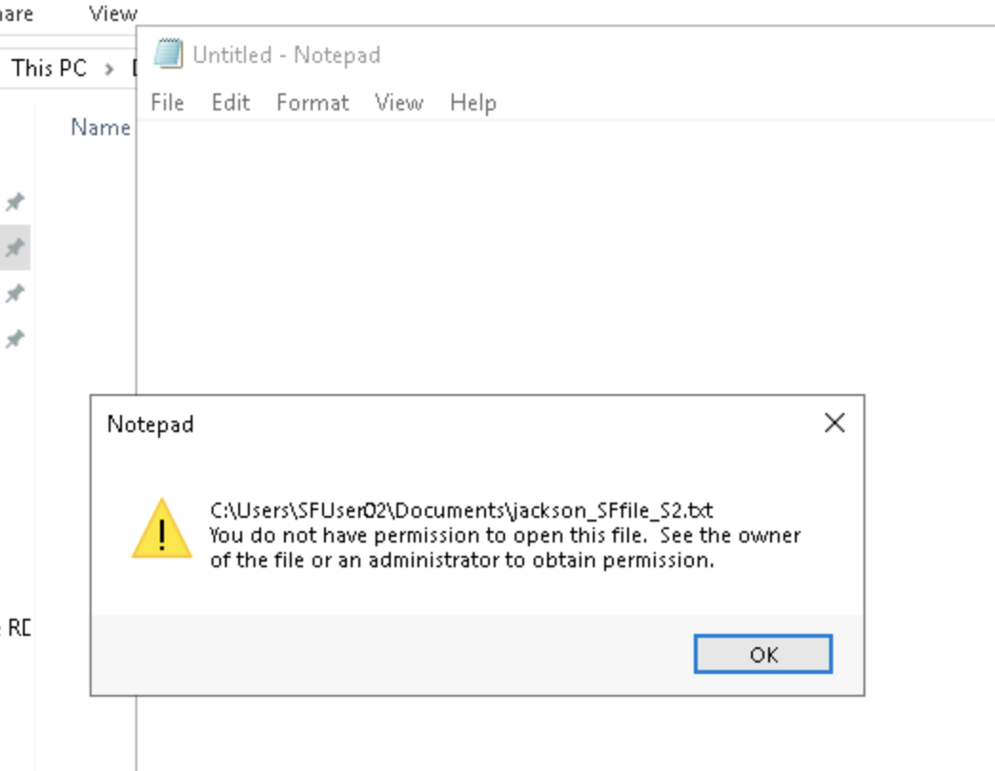

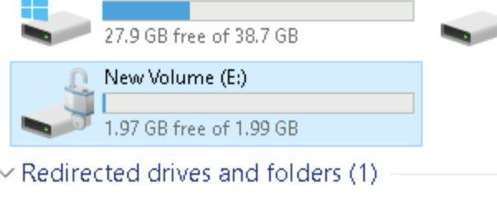

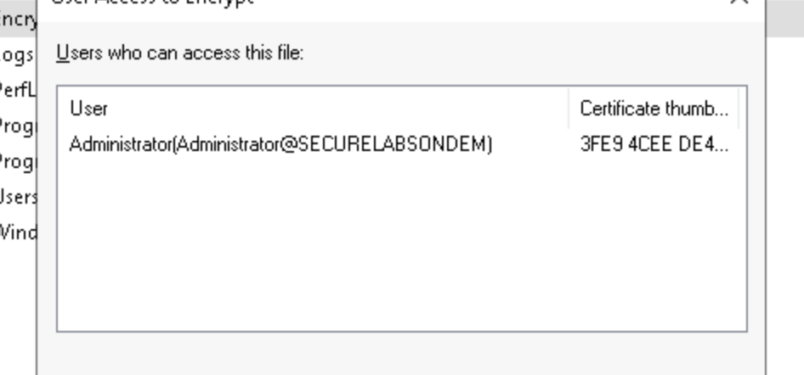

Section 3:

Part 1: Well I think there’s always two sides to this argument. One, it’s good to have knowledge of the weaknesses of your algorithms and know how to defeat them so they can be improved and data can for sure not be lost. But the other side means that you are releasing a program that is specifically designed to defeat your security. In my opinion, having the COFEE program defeats the point of the security in the first place. Even though there are advantages to having a program like this, some of which I am probably unware of still, I think having a strong encryption without that kind of a algorithm breaking program is good. The more I think ab out this the less sure I am about one being better than the other though… Both sides have pros and cons I feel.

Part 2: 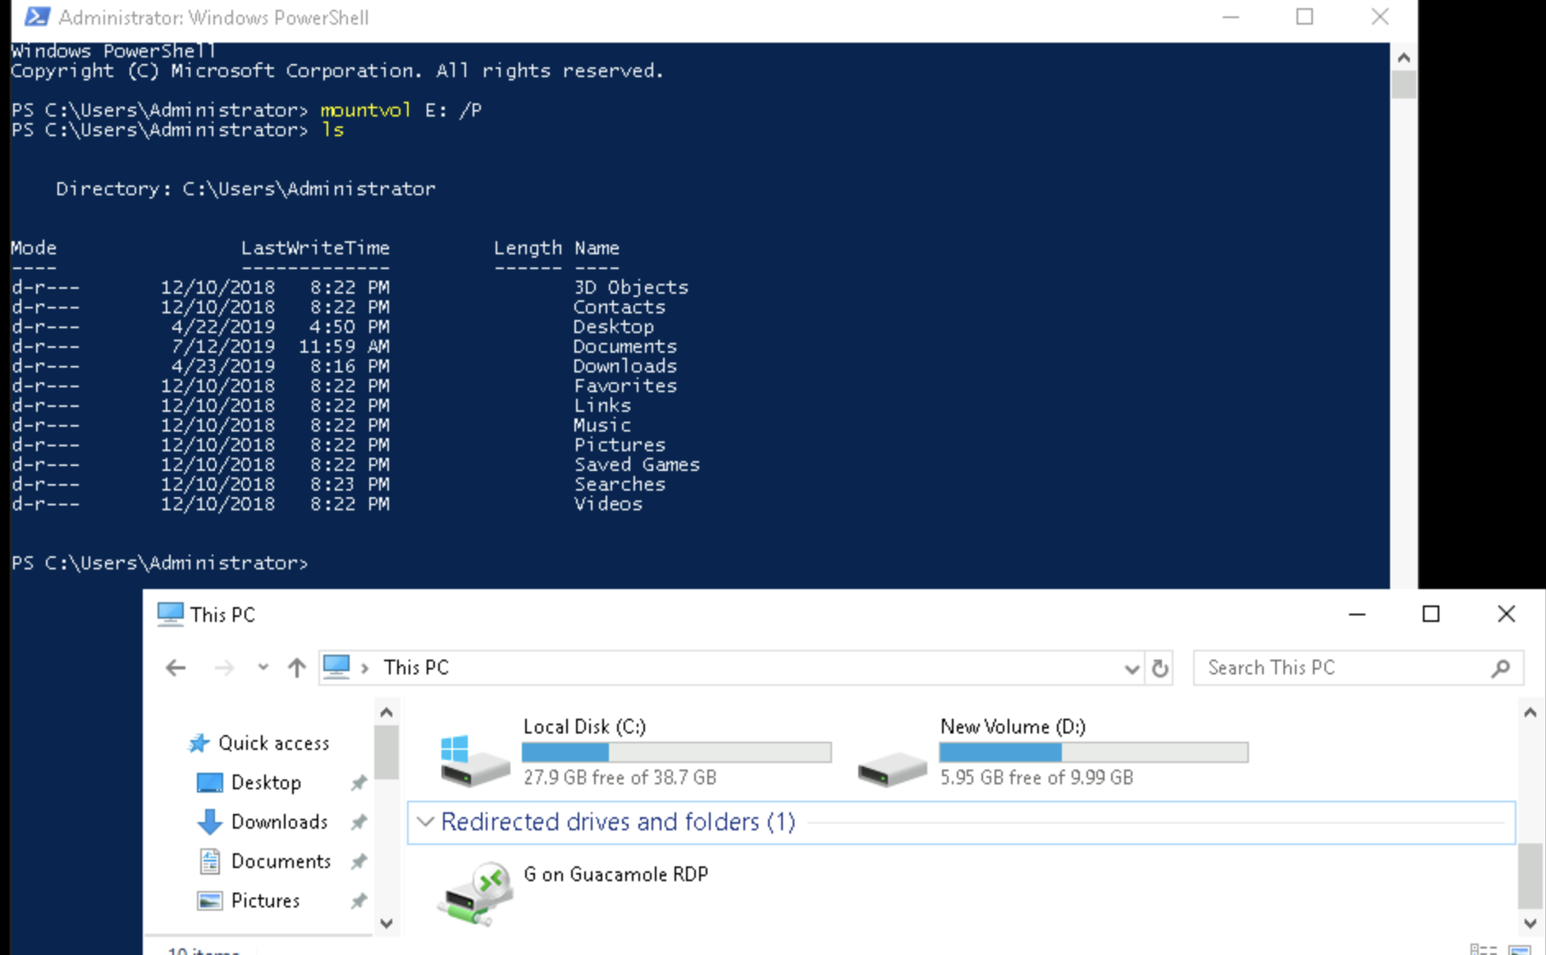

Part 3: 